Practical Automation Task

This task will give you an idea of what it is like to work as an Automation Developer in our organization and an opportunity to showcase your skills.
Considering the amount of time granted for this task, keep in mind that if you’re unable to complete all user stories it would be a priority to fine-tune the ones you were able to complete and test them well.

Task Description:
Below you will find user stories that are part of a process that would need to be automated.
Your task is to create an automated solution for this process which you will then need to demo and explain.
Upon completion or expiry of the deadline mentioned in the email, please send the source code of your solution back as well as any relevant comments about challenges, roadblocks, or other observations to the Hiring Manager.

Tools for the Task:
Please use any of the tools/languages listed out below. Please note: the order of the list is random – it doesn’t mean that Python is the most and C# the least preferred tool:
- Python
- Blue Prism
- UiPath
- Power Automate
- C#
Good Luck!

Transfer Funds - User Stories

Create Customer account
1. As a customer, I want to open Parabank (https://parabank.parasoft.com/parabank/index.htm).
2. As a customer, I want to register to the bank and create credentials.
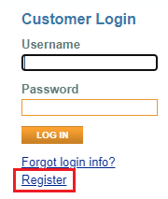
3. Register all the customers that you find in the excel file – user profiles.

Request a Loan for all the Bank accounts
4. As a customer, I want to create new account by navigating to the “Open New Account” functionality.
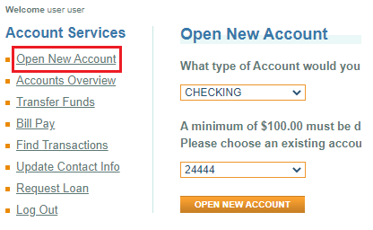
5. As a customer, I want to request a loan for 10000 $
6. As a customer I want to give a down payment of 20% of my initial deposit
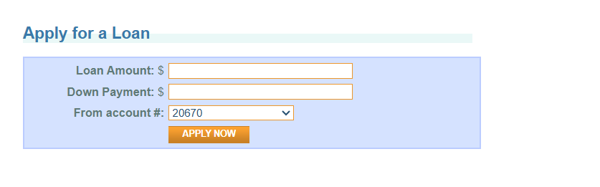
7. As a Customer I want a report of my freshly performed operations in EUR currency
8. As a customer, I want to log out from Parabank prior to shutting down the browser.
9. As a customer, I want to shut down the browser upon completion of the request.
Additional Requests:
Create a report in excel for Parabank operator that reflects the steps performed in the task in a meaningful way.
In the report you need to provide as additional information such as DOB, Debit Card number and CVV.

